安裝Access Medicine & Access Anesthesiology資料庫APP方法
1. 在院內登入Access Medicine醫學電子書資料庫:
https://accessmedicine.mhmedical.com/
2. 如下圖示操作:
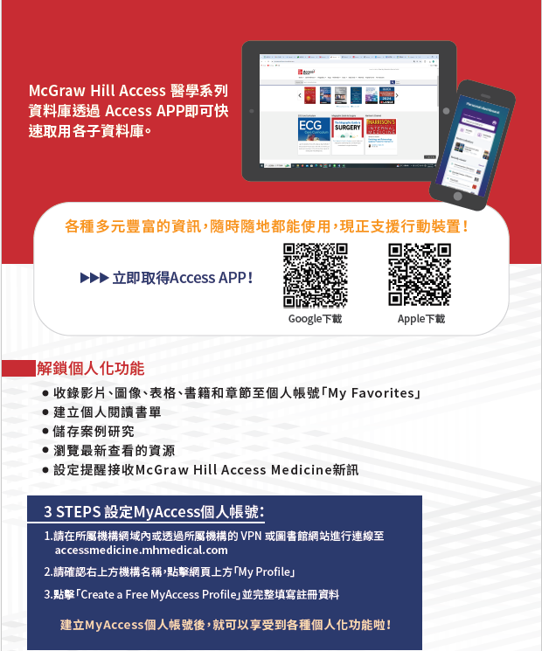

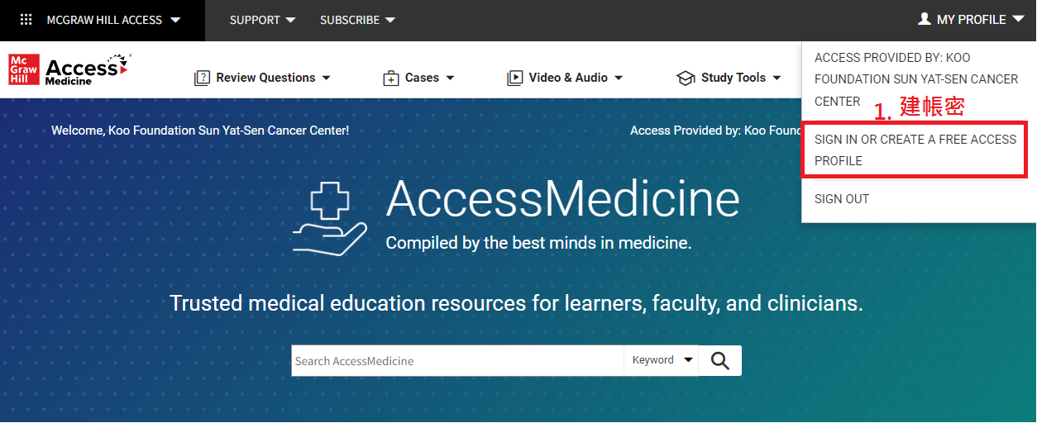
Access® app makes studying easier and more efficient

The Access mobile app is a personalized interactive learning solution where users can search vetted and trusted medical and allied health content across a variety of mediums that best fit their learning needs.

  
  



